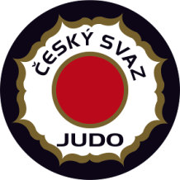


EJU OTC “Going for Gold”
Men / Women

2 - 8 March 2020 Nymburk - Czech Republic

Visa Application Form
tel.: +420 -233 355 280
fax: +420 -257 214 265
E-mail: sejudo@cstv.cz

FEDERATION Date, Stamp & Signature:

Our delegation needs the invitation from the_______ till the_______ of ________________ 2020.

We will apply for visas at the CZECH Embassy in __________________________ (country, city)

Surname | First Name | Date of Birth | Passport No | Date of issue | Date of expiry

