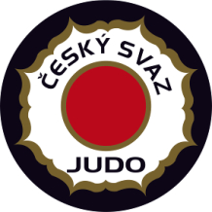

EJU Olympic Training Centre Men / Women

13 - 22 March 2014 Nymburk - Czech Republic
ROOMING LIST
Federation: Hotel:
No | Name | room | 12.3 | 13.3 | 14.3 | 15.3 | 16.3 | 17.3 | 18.3 | 19.3 | 20.3 | 21.3 | 22.3 | 23.3
example | Lukas Krpalek Alexandr Jurecka | double |  | in |  |  |  |  |  |  |  |  | out
1
2
3
4
5
6
7
8
9
10
11

