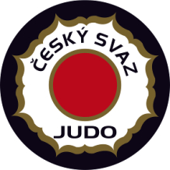

EJU Olympic Training Centre Men / Women

6 - 12 March 2017 Nymburk - Czech Republic
ROOMING LIST
Federation: Hotel:
No | Name | room | 5.3 | 6.3 | 7.3 | 8.3 | 9.3 | 10.3 | 11.3 | 12.3 | 13.3
 |  |  | Su | Mo | Tu | We | Th | Fr | Sa | Su | Mo
example | Lukas Krpalek  Jaromir Jezek | double |  | in |  |  |  |  |  | out
1
2
3
4
5
6
7
8
9
10
11

