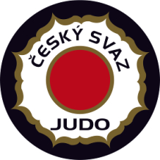

EJU Training Camp Juniors Men / Women

28 - 31 JULY 2014 Nymburk - Czech Republic
ROOMING LIST
Federation:
No | Name | room | 27.7. | 28.7. | 29.7. | 30.7 | 31.7. | 1.8.
ex1 | KOLCHEV YURY  ZHERDEV VICTOR | Double |  | in |  |  | out

