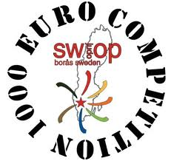

FIRST ENTRY
Federation

Club

E-mail

Phone

PARTICIPATION
 | WOMAN | MEN | OFFICIALS
Swedish Judo Open

Training Camp

Transfer to Finland

NUMBER OF REFEREES
Referees

