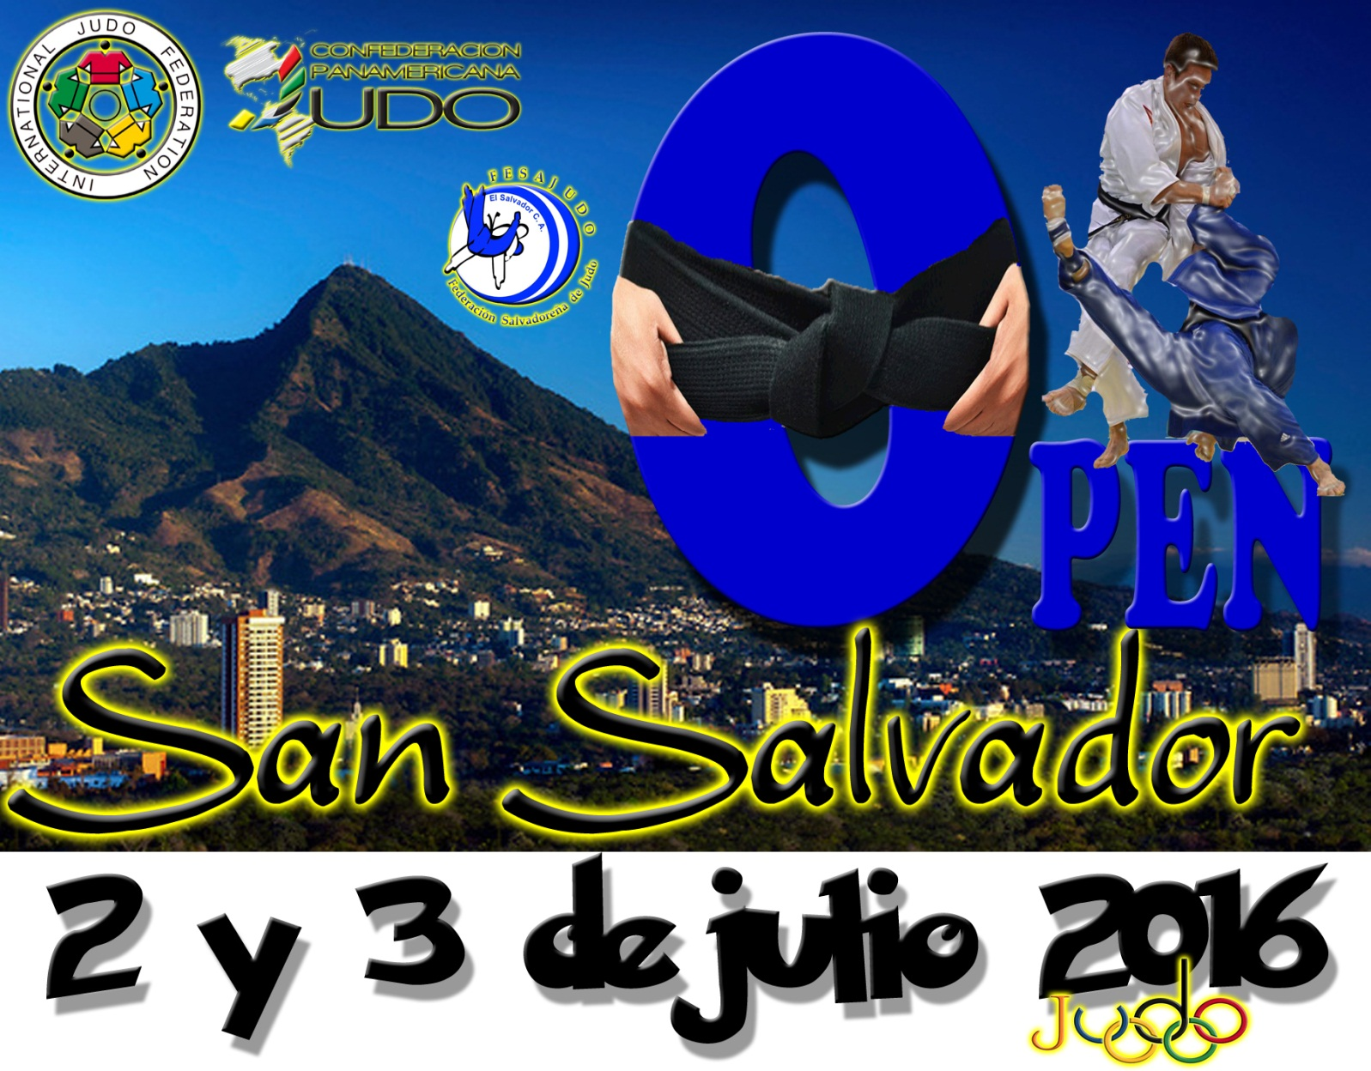
INVITATION
PANAMERICAN JUDO OPEN
SAN SALVADOR, EL SALVADOR 2016
June 30th to July3er

INTERNATIONAL CUPS
JUAN CARLOS VARGAS AND YANIRA VIGIL
July 4th

Dears Presidents to the National Judo Federations

Sr. Manuel Larrañaga
Presidente
Confederación Panamericana de Judo

Dears Presidents of each Federations affiliated to the International Judo Federation.
San Salvador, El Salvador once again assume the responsibility for conducting the Open Continental and give us an event of very high quality and organizational level.
On behalf the Pan American Judo Confederation invite you to be part of this great sporting event organized by the FESAJUDO; which will be held in the city of San Salvador, El Salvador on July 2 and 3, 2016.
In this event 100% of qualifying points for International Rankin will be awarded.
Judokas across America and the world ... are welcome. San Salvador will receive them with open arms.

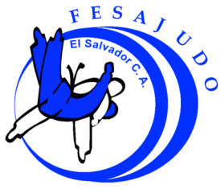
INVITATION – EL SALVADOR JUDO FEDERATION
SENIOR
PANAMERICAN JUDO OPEN
JUNE 30th to JJULY 3er
INTERNATIONAL CUPS JUAN CARLOS VARGAS and YANIRA VIGIL
JULY 4th
SAN SALVADOR, EL SALVADOR 2016
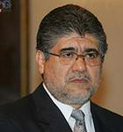
Lic. Luis Alonso Chévez
President
El Salvador Judo Federation

DEAR PRESIDENTS OF THE NATIONAL JUDO FEDERATIONS:

I am very glad this time to writing to you, to extend the warmest Invitations to participate in the Panamerican Judo Open and the International Judo Cups “Juan Carlos Vargas and Yanira Vigil”. Both Tournaments will be held in San Salvador City from June 30th to July 4th, 2016.

The Panamerican Judo Open is a Scoring event for the International Ranking 2016.
All Judo Federations affiliated to the IJF can participate at these tournaments.
Competitions will develop in senior categories for men and woman; these events have been organized so the participant teams make a single official weight for both events.

We annex regulations, program, registration forms, and flight itineraries.

Sincerely

Luis Alonso Chévez
President

INVITATION – EL SALVADOR JUDO FEDERATION
SENIOR PANAMERICAN JUDO OPEN
JUNE 30th to JULY 3er
INTERNATIONAL CUPS
JUAN CARLOS VARGAS and YANIRA VIGIL
JULY 4 th
SAN SALVADOR, EL SALVADOR 2016

Salvadorean Judo Federation
Condominio Torre Activa 3o level No 7 San Salvador, El Salvador. C.A.

Phones | (503) 22259170, 22259173, 25646788
E mails | Chevez1@integra.com.sv, luischevezm@hotmail.com  fesajudo@integra.com.sv, fesajudo@hotmail.com

PJC SPORTS Director
DATES | JUNE 30 th to JULY 4 th, 2016
Competitions Venue | Sports Palace Carlos “El Famoso” Hernández.  Address: Alameda Juan Pablo II, Goverment Center, San Salvador

PROGRAM
THURSDAY  June 30th | Arrivals: Delegations  Members PJC  Accreditation: 14.00 -18.00 Official Hotel (Intercontinental Hotel)
FRIDAY  July 1st | Arrivals: Delegations  8:00 - 13:00 Accreditation in Official Hotel (Intercontinental Hotel)  14:00 Draw Official Hotel (intercontinental Hotel)  15:00 Referee Clinic Official Hotel (Intercontinental Hotel)  18:00 - 19:00 No Official Weight (Intercontinental Hotel)  19:00 - 19:30 Official Weight (Intercontinental Hotel)
SATURDAY | 10.00 Opening Ceremony
July 2nd | 10:30 Preliminaries and Repechage  MEN: -60, -66, -73 kgs.  FEMALE. -48, -52. -57. -63 Kgs  Fights for BRONZE MEDALS and Finals  Awards Ceremony  Anti-Doping Control  18:00 - 19:00 No Official Weight (Intercontinental Hotel)  19:00 - 19:30 Official Weight (Intercontinental Hotel
SUNDAY  July 3er | 10:00 Preliminaries and Repechage:  MEN: -81, -90, -100, + 100 kgs.  FEMALE. -70, -78. +78 Kgs  Fights for BRONZE MEDALS and Finals  Awards Ceremony  Anti-Doping Control  THE DRAW OF THE INTERNATIONALS CUPS WILL BE INMEDIATLY AFTER FINISH THE CONTINENTAL OPEN  WEIGHT TO INTERNATIONAL CUPS:  18:00 -19:00 No Official Weight (Intercontinental Hotel)  19:00 - 19:30 Official Weight (Intercontinental Hotel)
MONDAY  July 4th | INTERNATIONAL CUPS  “JUAN CARLOS VARGAS AND YANIRA VIGIL”  9:00 Preliminaries and Repechage  MEN: -60, -66, -73, -81, -90, -100, + 100 kgs.  FEMALE. -48, -52, -57, -63, -70, -78. +78 Kgs  Fights for BRONZE MEDALS and Finals  Awards Ceremony
TUESDAY  July 5th | DEPARTURE

COMPETITION SISTEM | Tournaments will be conducted according to the Rules and IJF Sporting Code. Repechage will be applied in the last 8 competitors, the top eight world ranking competitors will be separated in the draw
PARTICIPATION | Each Country may enter maximum 4 competitors per weight category
JUDOGUIS | It is mandatory one blue and one white judogui for each competitor.  Judogui Control will be done through SOKUTEKI Rules approves by IJF, since January 2009 and "Red Label" de la FIJ,
ANTI-DOPING CONTROL | For only Panamerican Judo Open.
REFEREES | Referees must have licensed “A” o “B” class BY IJF
REGISTRATION | - Firs Registration May 10th, 2016 (NUMERICAL) FESAJUDO Form  - Hotel Reservation May 30th, 2016 FESAJUDO Form  - Final Registration June 10th, 2016 (NOMINAL) FESAJUDO Form
HOTEL RATES  HOTEL 5 STARS | Rates are per person per night. Include lodging, meals (Breakfast, lunch and dinner); transportation from airport to hotel, both ways; from the hotel to the competition venue, both ways  ROOM INTERCONTINENTAL HOTEL  Single $ 190.00 USD (Per person per night)  Double $ 160.00 USD (Per person per night)
MEDICAL SERVICE | The Organizing Committee will provide medical services during the competition, if a member of a delegation requires hospitalization or surgical intervention treatments while in El Salvador, each delegation will be responsible for cover these costs. So the Organizing Committee is excluded from liability for these effects.

IMPORTANT:
- To ensure your accommodation and lodging it is important that we bring the number of athletes and delegation members before May 30th NO EXCEPTIONS.
The Salvadoran Judo Federation won’t assume any responsibility for availability of accommodation and food in case of breach of the deadlines for registration and booking.

- Payments are in cash USD Bills, No Bank transfer, Credit cards or Traveler Checks are accepted

- Countries that not accept the accommodation options offered by the organizing committee, they are not provided transportation or food during their stay in the Country. And they must pay a penalty of $200.00 US Dollars per person.

- Registration Fee: $20.00 US Dollars per athlete, Officials don´t pay. This according to Regulations approved at the Panamerican Judo Confederation congress on December 2011

- The National Federation that makes a reservation and is not present on the site set without warning at least 48 hours’ notice must cancel the respective no show.

- ALL PAYMENTS MUST BE MADE AT THE TIME OF REGISTRATION.

Delegations requiring a visa or permission to enter our country can see page www.migracion.gob.sv / services / our services / foreigners / paperwork to enter El Salvador.

Sr. Manuel Larrañaga  President of Panamerican Judo Confederation | Luis Chévez  President of Salvadorian Judo Federation

First Inscription (NUMERICAL) May 10th, 2016

COUNTRY __________________

FEMALE

WEITH | Participants Number
-48
-52
-57
-63
-70
-78
+78

MALE

WEIGTH | Participants Number
-60
-66
-73
-81
-90
-100
+100

FIRST REGISTRATIONS (NUMERICAL) May 10th, 2016

COUNTRY __________________

OFFICIALS

FUNCTION | Participants Number
TOTAL

REFEREES

LICENSE | Participants Number
TOTAL

HOTEL RESERVATION: Deadline May 30th, 2016
FEDERATON _______________
HOTEL RESERVATION (CHECK IN 13:00)
ROOMS | DATE OF ARRIVAL | DATE OF DEPARTURE | NUMBER OF NIGHTS
SINGLE
SINGLE
SINGLE
SINGLE
DOUBLE
DOUBLE
DOUBLE
DOUBLE

FLIGHT INFORMATION
ARRIVALS
DATE | TIME | FLIGHT Number | NUMBER OF PEOPLE

DEPARTURE

DATE | TIME | FLIGHT Number | NUMBER OF PEOPLE

FINAL REGISTRATION (NOMINAL) June 10th, 2016
COUNTRY __________________
FEMALE
WEIGHT | NAMES | PASSPORT
-48
-52
-57
-63
-70
-78
+78

MALE
WEIGHT | NAMES | PASSPORT
-60
-66
-73
-81
-90
-100
+100

FINAL REGISTRATION (NOMINAL) June 10th, 2016
COUNTRY __________________

 | OFFICIALS
Number | Name | Function | Passport

 | REFEREES
Number | Name | License | Passport

COMPETITIONS VENUE

GYM
SPORTS PALACE
CARLOS “EL FAMOSO” HERNÁNDEZ INDES
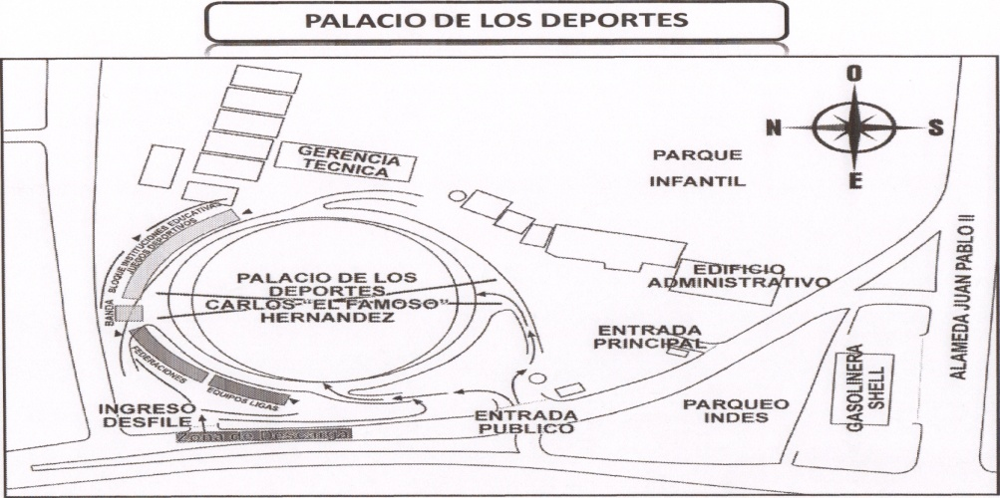

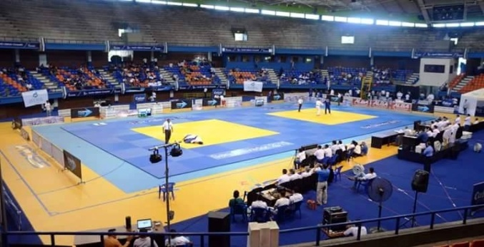
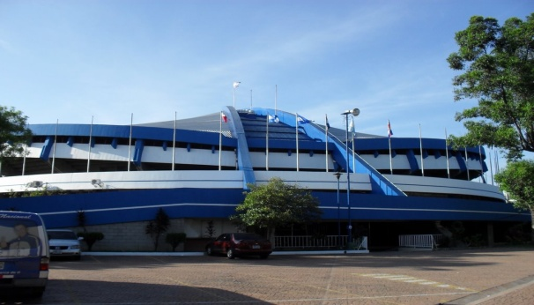

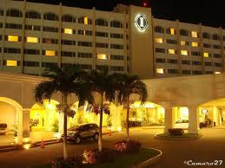
INTERCONTINENTAL HOTEL, EL SALVADOR

