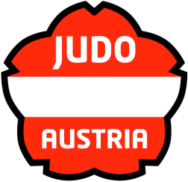
EJU OTC “GOING FOR GOLD”MITTERSILL 2013
Austria

ENTRY FORM
Please complete and return until latest 22nd of November, 2012.

Federation/Club
Contact:
Email address
Telephone number
Number of participants (total)
Officials
Female athletes
Male athletes

Hotel Category:
A |  | B |  |  | C
Single Rooms:  (requested number) |  | Single Rooms:  (requested number) |  |  | Single Rooms:  (requested number)

Board :
Bed & Breakfast |  | Half Board |  |  | Full Board

Travel Information:
Transfer requested |  | yes |  | no
ARRIVAL |  |  | DEPARTURE
Date of arrival |  |  | Date of departure
Airport/station |  |  | Airport/station
Arrival time |  |  | Departure time
Flight number |  |  | Flight number
from |  |  | to

Date | Stamp | Signature
EJU OTC “GOING FOR GOLD”MITTERSILL 2013
Austria

FINAL ENTRY
Please fill in with capital letters and return until latest 6th of December, 2012.
FEDERATION / CLUB:
 | Last name | First name | Function
1.
2.
3.
4.
5.
6.
7.
8.
9.
10.
11.
12.
13.
14.
15.
16.
17.
18.
19.
20.
21.
22.
23.
24.
25.

Date | Stamp | Signature

