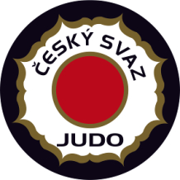
Prague European Judo Open
Prague – Czech Republic
March 05-06, 2022
tel.: +420 -233 355 280
fax: +420 -257 214 265
E-mail: sejudo@cstv.cz

Visa Application Form

FEDERATION XXX Date, Stamp & Signature XXX
Our delegation needs the invitation from the XXX till the XXX 2022.
We will apply for visas at the Embassy in XXX (country, city).
Contact person of the delegation XXX (name, email, mobile phone)

First Name | Surname | Nationality | Date of Birth | Passport No | Date of expiry | Position in the delegation | Date of Vaccination Completion | Vaccination type
 |  |  |  |  |  |  | XXX | XXX
(Doc/xls format only, NO PDF)

